**Support your local farmer**

[**http://articles.chicagotribune.com/2008-07-06/news/0807050398_1_local-food-organic-food-sales-organic-trade-association**](http://articles.chicagotribune.com/2008-07-06/news/0807050398_1_local-food-organic-food-sales-organic-trade-association)

**Movement to eat food grown within 100 miles of home is gaining traction**

July 06, 2008|By Gerry Smith, TRIBUNE REPORTER

Last month, Lenae Weichel embarked on an ambitious dietary experiment: to **feed** her family for a year with food produced **within** 100 miles of her Rockford home.

Inspired by a Vancouver couple who wrote a book on their "**100-mile diet**," she joined a **community-supported agriculture program**, visited her local farmers market and started growing fruits and vegetables in her backyard.

Weichel, 33, is an extreme example of a vibrant movement of "locavores," or consumers who try to **shorten** the distance between their food and its origin, largely from a desire to eat **fresher produce**, **support their local farmers** and **reduce the carbon pollution** associated with transporting goods.

Only a few set 100 miles as a strict limit; others might just seek produce from the Midwest. But eating **locally grown food**, an idea once limited to hard-core environmentalists, is gaining traction among mainstream consumers. Already the movement has inspired a slew of books, prompted restaurants to use local food as a selling point and established "locavore" as the Word of the Year for 2007, according to the Oxford American Dictionary.

Now Illinois is trying to turn that idea into a statewide phenomenon. Since January, a state-appointed task force has been meeting to make policy and funding recommendations to lawmakers to help the state feed itself.

But the local foods movement faces an uphill battle, and not just for locavores struggling to find certain foods, such as bananas and chocolate. For Illinois, the biggest obstacle may be meeting the **growing demand** on farmers from supermarkets, restaurants and people who want to buy locally grown food, task force members say.

Although Illinois boasts an abundance of rich farmland, the state imports more than 90 percent of its food, with most farmers growing corn and soybeans for export. The steady flow of agriculture out of Illinois frustrates local-food **advocates** who say the state is missing a significant economic opportunity.

"Here we are sitting in the heartland with the best prairie soils in the world," Debbie Hillman, co-founder of the Evanston Food Policy Council and a member of the task force. "Why are we sending our food dollars outside the state?"

Jim Slama, a task force member and president of FamilyFarmed.org, a nonprofit organization that supports local food systems, said: "We must prove to farmers that this market is here, that it's growing and that they can make money on it."

**LOCAVORE FOUNDERS**

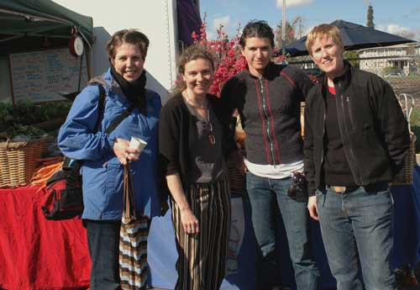

Jen Maiser, Jessica Prentice, Sage Van Wing, and Dede Sampson at the Berkeley Farmers' Market

**Why eat locally?**

Our food **travels** an average of 1,5OO miles **before ending up on our plates**. This globalization of the food **supply** has serious consequences for the **environment**, our **health**, our **communities** and our **taste buds**. Much of the food grown in the breadbasket surrounding us must be **shipped across** the country to distribution centers before it makes its **way back** to our **supermarket shelves**. Because uncounted costs of this **long distance journey** (air pollution and global warming, the ecological costs of large scale monoculture, the loss of family farms and local community dollar) are not paid for at the checkout counter, many of us do not think about them at all.

What is eaten by the great majority of North Americans comes from a **global everywhere**, yet from nowhere that we know in particular. How many of our children even know what a chicken eats or how an onion grows? The distance from which our food comes represents our separation from the knowledge of how and by whom **what we consume is produced, processed, and transported**. If the production, processing, and transport of what we eat is destructive of the land and of human community—as it very often is —how can we understand the implications of our own participation in the global food system when those **processes are located elsewhere** and are so obscured from us? How can we act responsibly and effectively for change if we do not understand how the food system works and our own role within it?

Some experts are locavore skeptics. To find out more, you can read the following articles:

**The Locavore myth**

<http://www.forbes.com/forbes/2009/0803/opinions-energy-locavores-on-my-mind.html>

**An Environmentalist on the Lie of Locavorism**

<http://observer.com/2013/04/the-lie-of-locavorism/>